The IILPM Annual Global Awards are set out to recognise exceptional achievements in Legal Project Management. The applicant must be a self-nominating entity, and may be required to attend an online interview where short-listed.
There is no application.
The application submission by be emailed to awards@iilpm.com no later than 31 October 2022, 5pm CET. Late applications will not be accepted.
AWARD CATEGORY
Please select the category of your application (mouse click on box):
☐ Innovation in LPM from a Law Firm or an Alternative Legal Service Provider; or
☐ Innovation in LPM from an In-house Legal Department
APPLICANT DETAILS
Client/partner/business user testimonies are welcome where appropriate
- Please state the name of your organisation.

- Please state the address of your organisation.

- Please state the name of your contact person.

- Please state the email address of your contact person.

- Please briefly describe your organisation and its services. (maximum of 200 words)

BASIS OF APPLICATION
- With a maximum of 2,000 words, please describe the innovation in LPM your organisation has successfully implemented during the last 12 months (from July 2021) responding to the four assessment questions below. (e.g., training or coaching programs, usage of technology, pricing practices, methodology and workplace tools)
What was achieved?

What were the key challenges and how were they resolved?

What were the outcomes?

How did you measure this success?

TERMS AND CONDITIONS
The signatory, on behalf of the applicant organisation, confirms:
- the applicant organisation agrees to the Terms and Conditions of this application.
- the applicant organisation has achieved a maturity level 3 in at least four categories of the LPM Organisational Maturity Model (see diagram in this application).
- the information provided in this application is accurate and factual.
- the information provided has not exceeded the maximum word counts and has responded to all question, that will otherwise render the application invalid.
- the information provided may be used to promote the short-listed candidates and winners where any specific client information will be withheld.
- the applicant organisation acknowledges that the judging panel decision is final.
- the application organisation indemnities the International Institute of Legal Project Management against any claims associated with this application or the awards.
- the International Institute of Legal Project Management reserves the right to validate the information with the organisation or any mentioned client.
- the applicant organisation has met the submission date requirements.
I agree with the Terms and Conditions of this agreement on behalf of the applicant organisation:
Contact Person’s Signature:
Submission Date:

LPM ORGANISATIONAL MATURITY MODEL

An applicant organisation must have met a maturity level 3 in at least four categories of the LPM Organisational Maturity Model below:

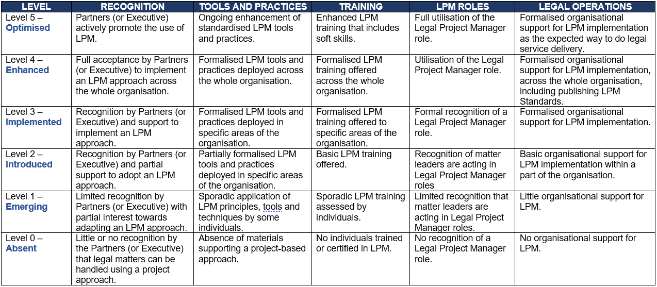

FOR MORE INFORMATION

Please visit https://www.iilpm.com/awards/ for award application information.
Specific questions can be addressed to ignaz.fuesgen@smartvokat.com.

SUBMISSION INSTRUCTION

Please email your completed application to awards@iilpm.com.

Please visit https://www.iilpm.com/awards/ for the award application information.

